# Retail Store Discounts

## Overview

This project implements a discount calculation system for a retail store using Java and Spring Boot. It includes unit tests to achieve good code coverage and follows object-oriented programming principles.

### Prerequisites

- Java 8
- Maven

### Building the Project
To build the project, run the following command:
mvn clean install

### Running the Tests
To run the tests, use the following command:
mvn test

### Assumptions and Decisions
Only one percentage-based discount can be applied per bill.
Percentage-based discounts do not apply to groceries.
For every $100 on the bill, there is a $5 discount.

UML Diagram
Key classes which are part of spring boot application and there description is as follows:
- User, Item, and Bill are model classes representing the entities.
- DiscountService is an interface defining the contract for calculating the net payable amount.
- DiscountServiceImpl implements DiscountService and contains the core logic for discount calculation.
- DiscountStrategy is an interface for applying different discount strategies.
- EmployeeDiscountStrategy, AffiliateDiscountStrategy, and CustomerDiscountStrategy implement DiscountStrategy for different user types.
- DiscountStrategyFactory provides the appropriate discount strategy based on the user type.
- DiscountController is a REST controller that handles requests and uses DiscountService to calculate the discount.
- UserType is an enum representing different user roles.
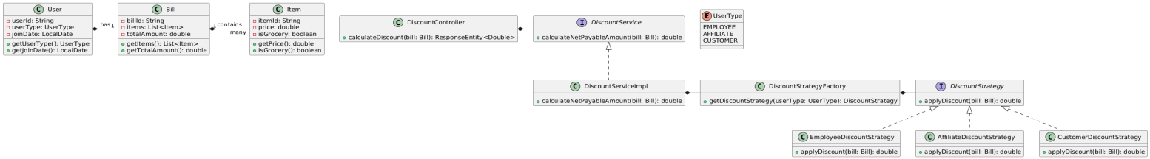

JUnit test cases Coverage 97.9%